AIUE Proceedings of the XX Industrial and Commercial Use of Energy Conference 20XX

Manuscript Track: (Please choose and preserve only one track most relevant to your manuscript)
TITLE OF PAPER

Author A* , Author B , Author C,.
Abstract:
The length of abstract must be limited to 200 words.
Keywords:
Maximum of 6 keywords are allowed.

*Corresponding Author Email:
\

Introduction
The introduction onwards the manuscript should be in two columns as per the TEXT styles in this document. The participating authors are advised to strictly adhere to the guidelines in this document on the manuscript preparation and submission. The completed manuscripts are to be submitted to the link on the conference website and/or emailed with the subject of the email as the ‘Title’ of the manuscript. For more details and for conference registrations please visit http://www.aiue.co.za/

Methodology

Sub-Section
Maximum of 3 headings allowed in the document. The main heading signifies the major section preceded by numbering in Roman numeral.

Experimentation

Stage 1
This is the heading 2 as subsection of the respective major section.

Stage 1 Findings
This is the heading 3 as a sub part of the respective sub section if required.

Results and Discussion
The entire manuscript including references must not exceed 6 pages. The caption for tables must be placed above the table. Caption for figures must be placed below the figure. The sample Table and Figure details are given in this document. The figures as depicted in Fig. 1 and tables as tabulated

in Table 1 can have footnotes as shown in this document. Authors are advised to insert high resolution images. Authors are also advised to insert tabulated data in a typed text/numbers format. The citations could have a mention with a number inside a square [ ] bracket e.g. [5]. The list of references should follow the chronology of the document. XYZ College of Engineering advises authors to submit original research/review work for consideration of peer review procedure. All the submissions should be verified for the acceptable plagiarism levels against the list of references provided by authors.

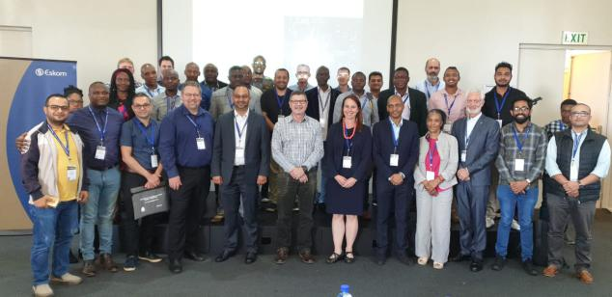
Fig. 1 Energy Conference [6]

Conclusions
The review papers may have Summary and Outlook as the concluding section. Names of the sections are indicative as per the standard practice. The participating authors to the approval of the peer review committee may choose to customize.
Table 1 PG courses at XYZ College of Engineering [6]
Dept. | Intake
Computer Applications | 18
Civil Engineering | 18
Electrical Engineering | 18
Mechanical Engineering | 18
All submitted manuscripts would be peer reviewed and only selected manuscripts after revisions would be considered for online hosting on SSRN Elsevier conference proceedings.

References
- Author, “Title of chapter in the book,” in Title of His Published Book, xth ed. City of Publisher, Country
- Author Name. (year, month). Title. Journal. [Type of medium]. volume (issue), pages. Available: site/path/file
- Author Name. (year, month). Title. Presented at Conference title. [Type of Medium]. Available: site/path/file
- Name of the invention, by inventor’s name. (year, month day). Patent Number [Type of medium]. Available: site/path/file
- Author Name, “Title of patent,” U.S. Patent x xxx xxx, Abbrev. Month, day, year.
- Author Name, “Title of paper,” in Abbreviated Name of Conf., City of Conf., Abbrev. State (if given), year, pp. xxxxxx.
- Author Name, “Title of the presented paper,” presented at the 2nd Int. Conf. Solid Freeform, Munich, Germany, Nov. 3-4, 1964.
- Author Name, “Title of dissertation,” Ph.D. dissertation, Abbrev. Dept., Abbrev. Univ., City of Univ., Abbrev. State, year.
- Author Name, “Title of paper,” unpublished.
- Author Name, private communication, Abbrev. Month, year.

Author Biographical Statements
Photograph of Author A | Biographical Statement for Author A and Affiliation
Photograph of Author B | Biographical Statement for Author B and Affiliation
Photograph of Author C | Biographical Statement for Author C and Affiliation

¹ Energy Conferences
PG courses on offer at XYZ College of Engineering

